CSI 422 Progress Report
April 19th, 2004.

Title:
Gestures Speak Louder Than Emoticons:
Building on the current expression limitations of textual chat with virtual,
non-verbal communication improvements.

Student:
Eldon Marks

Department of Computer Science
Faculty of Natural Sciences
University of Guyana
eternal_don@yahoo.com

Supervisors:

Internal: Mr. M. Williams
University of Guyana

Introduction

The following progress report reflects the developments made on the project entitled “Gestures Speak Louder Than Emoticons.” The significance of this project centers on eliminating miscommunication in instant text messaging. This project attempts to integrate the expressive dimension of gestures and facial expressions, through animated characters, into basic instant messaging. The aim is to produce a solution that improves communication between chatters by incorporating important attributes of face-to-face conversation. These developments span a period from March 1st,2004 to April 19th 2004 and are listed below.
- Background project research
- Software model design and construction
- Creation and integration of animations
- Development of the GUI of the private message window.
- Development and implementation of the text analysis model
- Development of a refined protocol for the chat system

Based on the rate at which these developments are made, the completion date of the project is estimated to be May 25th, 2004.
This report will provide a progress summary in which each major development is expanded on. The problems encountered during these developments will then be covered after which all the changes made in the project plan will be documented. Finally the report will provide a review of the current project state.

Progress Summary

The programming of the project was done in Java since it provides a flexible, robust and platform independent base to develop an application of this nature.

Background project research –
- Researched the most common of miscommunications in textual chat.
    - Based on saved chat logs, instances of sarcasm and humor were most commonly attributed to miscommunication.
    - Concluded that the absence of facial expressions was reason.

- Researched the general human emotion categories.
    - The general human emotion categories were needed to define the gestures that would have to be included in the application.
- Interviewed three avid chatters to gain their opinion on the concept of gesture enhanced text chat.
    - The responses were all positive. One of the chatters recalled an argument that started because of a misinterpreted smiley face.

Software model design and construction –
- Created the client-server base application capable of multiple client connections and private messaging.
    - The connectivity was achieved using sockets.
    - The multiple client connections were handled on the server by creating a thread and a socket for each connected client and saving the socket’s output stream in a hash table with the client name as the key. Iterating through the hash table, retrieving each output stream and transmitting the particular message, sends messages to all connected clients.
    - Private messaging was done by including a simple escape sequence before the message. (//relayPM "to" "from" …). The server would receive this, break up the string and send it to the particular client instead of to the chat room.

- Developed a simple message based protocol to send and receive remote commands between client and server.
    - Other ‘simple escape sequences’ were created as well. One to handle the updating of the client list on the client machine ("//list" "chatter1" "chatter2"…) and one to receive an incoming private message ("//pm "from" "to"…).
- Created simple client, private message window and server GUI’s.
    - Below is a screenshot of the client GUI.
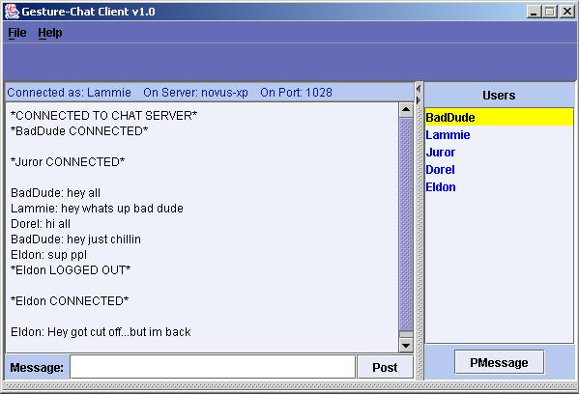

Fig. 1

Creation and integration of animations –
- Created a series of animation sequences in the form of JPEG images of a test character.
    - The character was modeled using Poser 5. Each animation was modeled frame-by-frame and finally exported as JPEGs.
- Developed a special component to display the images in sequence to simulate an animation. This was called the ‘Character Sequencer’.
    - The sequencer first loaded the frames to be animated into a vector.
    - An image icon was used to display individual frames of the animation. Using a Timer to fire at regular intervals sequenced the animation. On each fire, the next frame in the vector was displayed which created an illusion of smooth animation.
- Provided extra controls to change animation sequences.

Development of the private message window GUI –
- Included the character sequencer in the private message window.
- Created a message box to display pop-up messages in a callout box.
    - This displays a single incoming chat line within a callout box extending from the animated character.

- Created user interface components to send and display messages and gestures
    - Tabbed panes were used to contain these components to save space.
    - The tabbed panes were added to a layered pane to give a ‘heads up display’ view over the remote chatter’s character.
- Refined the UI.
    - Attached actions to most of the UI components mainly to trigger gestures and send special callout box messages.
    - Included formatted text in the conversation log box.
    - The following is a screen shot of the private message window:
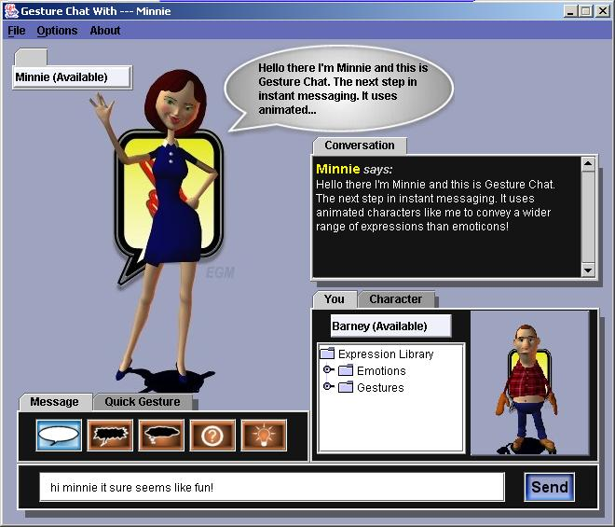

Fig. 2

Development and implementation of the text analysis model
- Developed a special object to detect words or phrases in inputted text that can be represented by gestures. This was called the ‘Message Parser.’
    - The message parser works with an external file called ‘library.ini’ which contains common text phrases and words mapped to gestures e.g. hey = wave-hello. The message parser hashes these key value pairs and uses this hash to detect and automatically trigger gestures.
- Implemented the message parser in the private message window.

Development of a refined protocol for the chat system
- Modularized the protocol source code on both client and server side to make the programming more manageable.
- Refined and built the client and server protocols to include the text transmission as well as the gesture transmission.

The major tasks to be completed are summarized in the following Gantt chart.

 |  | April |  |  |  |  | May |  |  |  |  | June |  |  | July
Task | Duration | 19 | 23 | 26 | 3 | 10 | 17 | 24 | 29 | 30 | 7 | 14 | 21 | 28 | 2
Superficial Developments
Develop at least 3 more virtual characters. | 1 week
Develop Client user interface. | 2 weeks
Second Progress Report May 29th |  |  |  |  |  |  |  |  | PR2
Beta test software | 1 week
Make final adjustments and refinements | 3 days
Tweak software | 4 days
Testing and debugging | 1 week
Write development notes
Report
Plan | 1 week
Review section notes | 1 week
Compile section notes | 1 week
Produce final report | 2 weeks
Report Due |  |  |  |  |  |  |  |  |  |  |  |  |  |  | FIN

Problems Encountered

During the development, the major problem encountered was program efficiency. It was noticed that the character sequencer requires a relatively great deal of memory and processor resources when animating the sequences. Since the private message window creates two instances of the character sequencer, one for the remote chatter and one for the local chatter, this seriously degrades performance on a low-end machine.

Overall Assessment of the Project

The development of the project reflects quite a productive outcome so far. According to the schedule, the major functionality is implemented a month in advance. What actually remains to be done does not call for drastic source code changes and this is more than satisfactory.

